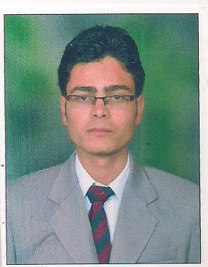  Correspondence Address:  SACHIN MISHRA  H no.8850, St. no’1, New Vijay nagger chuhar purr road, Haibowal kalan ,Ludhiana.  State: Punjab  Country: INDIA  Pin : 141002  Ph : no.  7837303682  E-Mail:  Mishrasachin218@gmail.com  PERSONAL DATA  Father’s Name:  Vijendra kumar,  Mother’s Name:  Sunita mishra  Date of Birth:  28-08-1993  Gender:  Male  Blood group:  B+  Weight:  50k  Height  162.5 cm (5.2 ft)  Nationality:  Indian  Marital Status:  Single  Languages known:  English, Hindi & Punjabi  Date:  Place: | Career Objective  To seek a challenging position and to dedicate my service to a reputed organization to expose my talents and skills.  Academic Details  Graduation  Technical Skills  Strengths  - Hardworking  - Consistent Performer  - Disciplined  Hobbies  - Playing cricket,  - Surfing net  - Listening songs  Declaration  I hereby declare that the information furnished above is true to the best of my knowledge.  Industry Experience. Six month’s  From:- Radisson Blu  Signature…  Date.
  Institute | PCTE: Institute of Hotel Management
  University | Punjab Technical University
  Degree | Pursuing Bachelors of hotel management and catering  technology
  Academic qualification | University/ Board | Institute | Aggregate
  10th | P.S.E.B. | Sana tan Vida mandir, seen sec school. | 50.73%
  12th | P.S.E.B. | Sana tan Vida mandir, sen sec school. | 55%
  COMPUTER KNOWLEDGE | Microsoft office: Microsoft Word, PowerPoint, Excel, Access  Internet Explorer

